# F-SCORE vs number of clusters

1. EM + WordNet removal + FastText Trained on homeautomation Wikipedia corpora

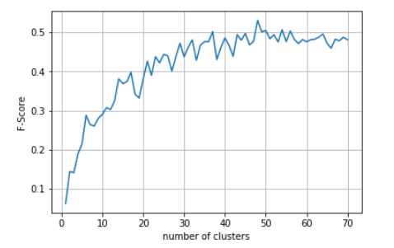

1. EM + WordNet removal + FastText pretrained on wikinews

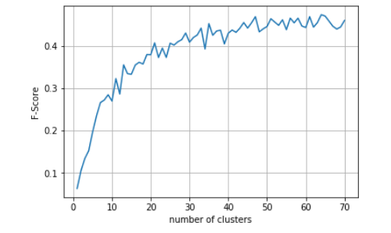

1. EM + without WordNet removal + FastText Trained on homeautomation Wikipedia corpora

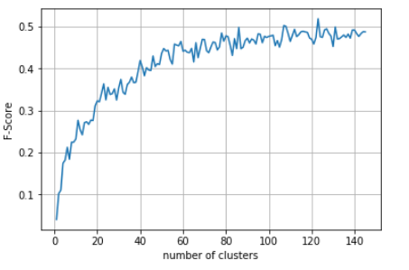

1. EM + without WordNet removal + FastText pretrained on wikinews

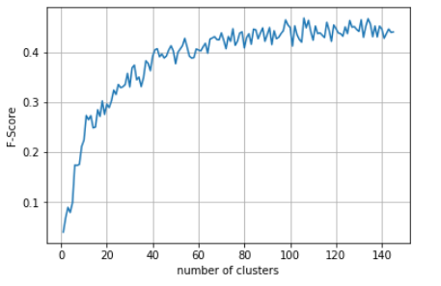

1. KM + WordNet removal + FastText Trained on homeautomation Wikipedia corpora

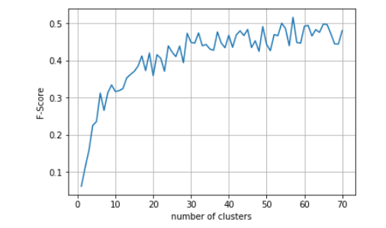

1. KM + WordNet removal + FastText pretrained on wikinews

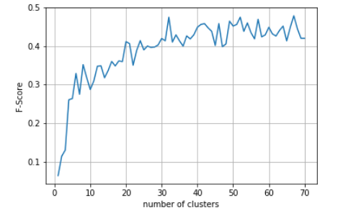

1. KM + without WordNet removal + FastText Trained on homeautomation Wikipedia corpora

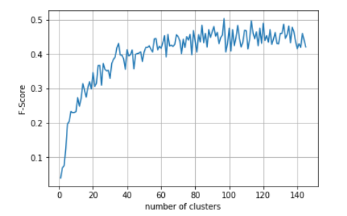

1. KM + without WordNet removal + FastText pretrained on wikinews

